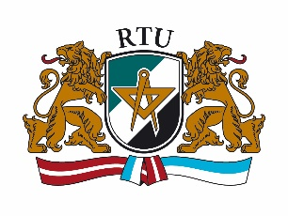 | Application Form  5th INTERNATIONAL STAFF TRAINING WEEK  May 23 – 27, 2016  Riga Technical University
Title:
Surname:
Name:
City and country:
University:
Department:
Position:
Main responsibilities:

Contact data
Address:
E-mail:
Mobile telephone number:

Erasmus code:

Name and e-mail of Erasmus coordinator at your institution:

Please state the reasons for participation at the International Week:

Individual meetings
(please indicate 3 choices (1, 2, 3) in order of preference)
Faculty of Architecture and Urban Planning
Faculty of Civil Engineering
Faculty of Computer Science and Information Technology
Faculty of Electronics and Telecommunications
Faculty of Engineering Economics and Management
Faculty of E-Learning Technologies and Humanities
Faculty of Materials Science and Applied Chemistry
Faculty of Power and Electrical Engineering
Faculty of Mechanical Engineering, Transport and Aeronautics
Riga Business School
Scientific Library
International Relations Department
Foreign Students Department
Other (please specify):
Social program  (60 EUR to be paid in cash during registration)  - Welcome dinner (Monday, 23 May)  - Riga city tour (Tuesday, 24 May)  - Tour to Jūrmala (Thursday, 26 May) | YES | NO
Please send your completed application form before 7 March 2016 to jolanta.jurevica@rtu.lv

