The Windesheim 2021 SDG Generation Festival
There is No Transition without Transformation: Educating for the Future We Want

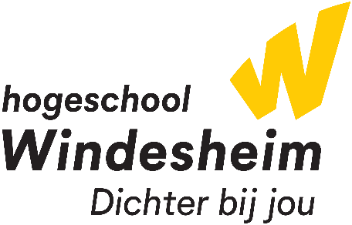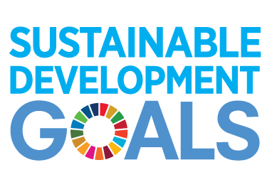

Date: 11, 12 and 13 October

Windesheim’s 2021 SDG Generation Festival explores the role of education in realising the Sustainable Development Goals and the transition to a sustainable world.

Thus, we invite you to share your stories, methods, experiences, case-studies and ideas on the following topics.

- Best practices in the integration of the SDGs in educational settings.

- Innovative methodologies that integrate education for sustainable development.

- Collaborative practices among local partners for the realisation of the SDG agenda.

- Future scenarios on education for sustainability.

You may deliver your session in a variety of formats (below); however, it should address one of the topics just mentioned or respond to one of these questions:

- What is the role of education in accelerating the SDG agenda or the EU Green Deal?
- How do educational institutions build partnerships (and with whom) to transform our local, regional, or national economic systems?
- What do effective partnerships for sustainability look like? How can they be replicated?
- What is your vision of an ideal sustainability education? How do we create it?

Please, send the completed form to sdggeneration@windesheim.nl no later than 8th July.

Title of your session | Write a brief and inviting title for your session.
Session format | - Workshop (45 or 90 min.)  - Ted Talk style presentation (15 min.)  - Inspirational story (30 to 40 min.)  - Showcase of best practices (30 to 40 min.)
What? | Please list your session’s goal and one or two learning objectives.
Why? | Please explain the relevance of your session to the festival’s topics.
Who? | Please describe your session’s target group(s) (e.g., educators, business leaders, managers, students, etc.)
Delivery: On campus or digitally? English or Dutch? | Would you prefer to conduct your session online or offline (at Windesheim University’s Zwolle campus)? Can you deliver your session in English, Dutch or both?
Facilities and equipment? | What facilities and equipment do you need to deliver your session?
Bio | Please include a 150-word bio with your relevant credentials and contact information including an e-mail address. Please, indicate if you are happy to share any of these contact details publicly.
