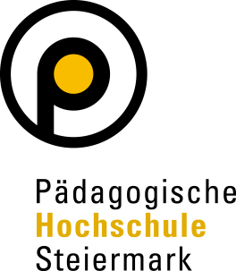

Declaration of consent

Consent to publication

I, ___________________________________, agree that my personal text and pictures attached to this agreement will be published in the Erasmus+ Journal (www.erasmus-journal.eu), on the website (www.phst.at) and on the social media channels (Facebook and Instagram) of the University College of Teacher Education Styria.
In addition, I expressly confirm that I have the right to use these texts and images and to make them available to the University College of Teacher Education Styria for the above-mentioned publication.
Should I revoke this consent, for whatever reason, I grant a grace period of 10 months for all published material with my picture. For online use, I agree that my image will be removed from the sources of the University College of Teacher Education Styria, but that the University College of Teacher Education Styria will not be held responsible for any further use, in particular to prevent any dissemination by third parties.

_______________________________________
Date and Signature::

